**Name: ___­­­­­­­­­__________________________**

**Static**

**Learning Objectives:**

* Students will be able to determine the variables that affect how positive and negative objects interact.
* Students will be able to predict how positive and negative objects will interact.

1. You and the class just made some observations with balloons – sticking and repelling.

Discuss with your partner your ideas about **why** the balloons would stick to things (like hair) after rubbing on your head? And repel from each other?

**Use words and pictures to describe your ideas** about what might be going on.

______________________________________ ______________________________________   
______________________________________   
______________________________________

______________________________________

2. Let’s look at the **Balloons and Static Electricity simulation**. <https://phet.colorado.edu/en/simulation/balloons-and-static-electricity>

1. Explore the simulation.   
   How can you make the balloon stick to the sweater?   
   __________________________________________________________________________________________________________________________________________________________  
   What makes it stick weakly versus strongly?

__________________________________________________________________________________________________________________________________________________________

1. How do the plus or minus symbols help you decide whether something attracts or repels?

__________________________________________________________________________________________________________________________________________________________

1. Talk about how your observations support, change or add to your ideas from Question 1 and about what affects whether things attract or repel. Then **revise your ideas from Question 1**.

3. With you partner, test your ideas about attraction and repulsion using the **Electric Field Hockey** simulation in the **Practice mode**. <http://www.physicsclassroom.com/Physics-Interactives/Static-Electricity/Put-the-Charge-in-the-Goal/Put-the-Charge-in-the-Goal-Interactive>

Play with the sim and talk with your partner about ideas that help you SCORE!

Now, develop strategies for the following challenges:

|  |  |
| --- | --- |
| Make a GOAL where puck takes the  **SHORTEST amount of time** to get to the goal | Make a GOAL where puck takes the  **LONGEST amount of time** to get to the goal |
| **Draw your strategy** for placing  positives or negatives  in the picture below.    What **rules** are you using to determine  **which direction** the puck moves?  _______________________________  _______________________________  _______________________________  _______________________________  What **rules** are you using to determine  **how fast** the puck moves?  _______________________________  _______________________________  _______________________________  _______________________________  _______________________________ | **Draw your strategy** for placing  positive or negative pucks  in the picture below  What **rules** are you using to determine  **which direction** the puck moves?  _______________________________  _______________________________  _______________________________  _______________________________  What **rules** are you using to determine  **how fast** the puck moves?  _______________________________  _______________________________  _______________________________  _______________________________  _______________________________ |
|  |  |

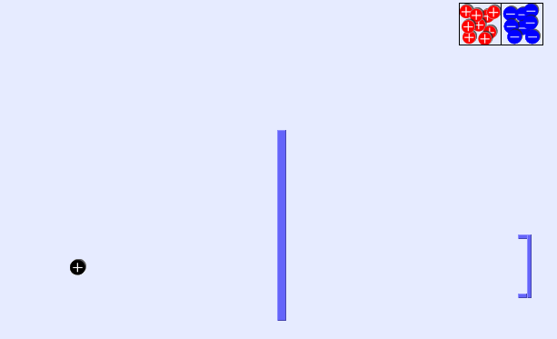4. **Draw** where you might put pucks to get a goal with the **fewest pucks.**

**Explain why this works:**____________________

____________________

____________________

____________________

____________________

____________________

5. Reflect on your ideas from Questions 1&2 and your data from Questions 3&4. How do your observations support, change or **add** to your ideas about…

**…whether two objects will attract and repel?**

**…how strongly they attract or repel?**

**Revise your explanation from Question 1.**